**Project Design Phase-II**

**Technology Stack (Architecture & Stack)**

|  |  |
| --- | --- |
| Date | 28 June 2025 |
| Team ID | LTVIP2025TMID53030 |
| Project Name | Learnhub : Your Center For Skill Enhancement |
| Maximum Marks | 4 Marks |

**Technical Architecture:**

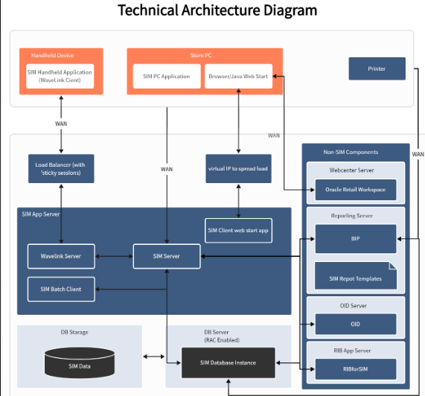

**Table-1 : Components & Technologies:**

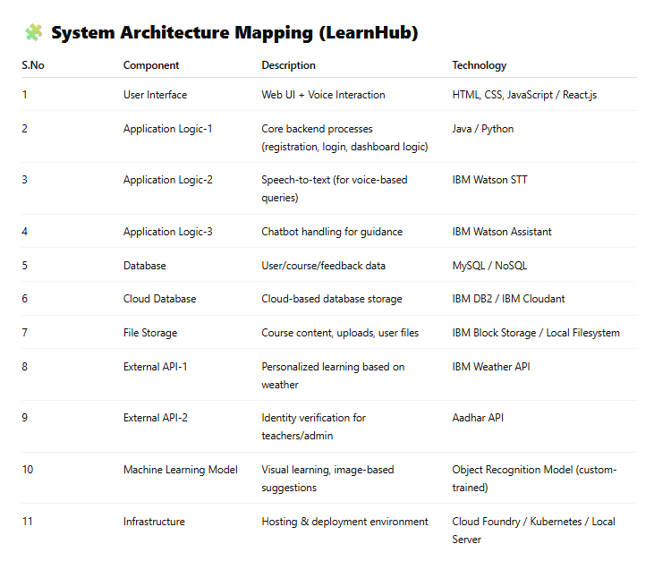

**Table-2: Application Characteristics:**

